# ISLAMIC UNIVERSITY OF TECHNOLOGY

# Organization of Islamic Cooperation

# Board Bazar, Gazipur

# Lab 03

# Study of Operational Amplifier as an Inverter, Inverting Amplifier, Adder, Integrator, Differentiator, Non-inverting Amplifier

# EEE 4484

**Task 2**

Circuit Diagram



Wave Shapes

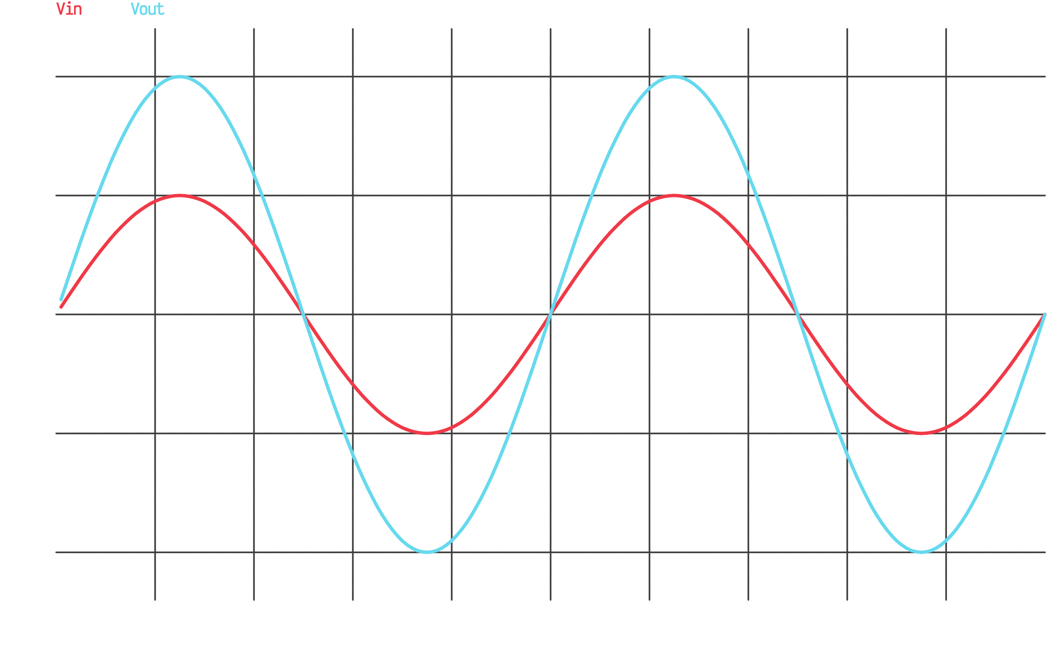

$$V_{out}=+\left(1+\frac{R_{F}}{R_{1}}\right)×V_{in}$$

$$A_{v}=\frac{V_{out}}{V_{in}}$$

$$=1+\frac{R_{F}}{R_{1}}$$

$$=1+\frac{10kΩ}{10kΩ}$$

$$=2$$

**Task 3**

Circuit Diagram



Wave Shapes

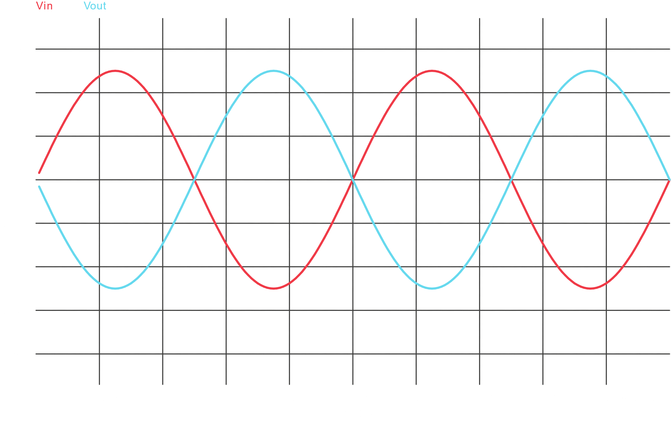

$$A_{v}=\frac{V_{out}}{V_{in}}$$

$$=-\frac{R_{F}}{R_{i}}$$

$$=-\frac{10kΩ}{10kΩ}$$

$$=-1$$

**Task 4**

Circuit Diagram



Wave Shapes

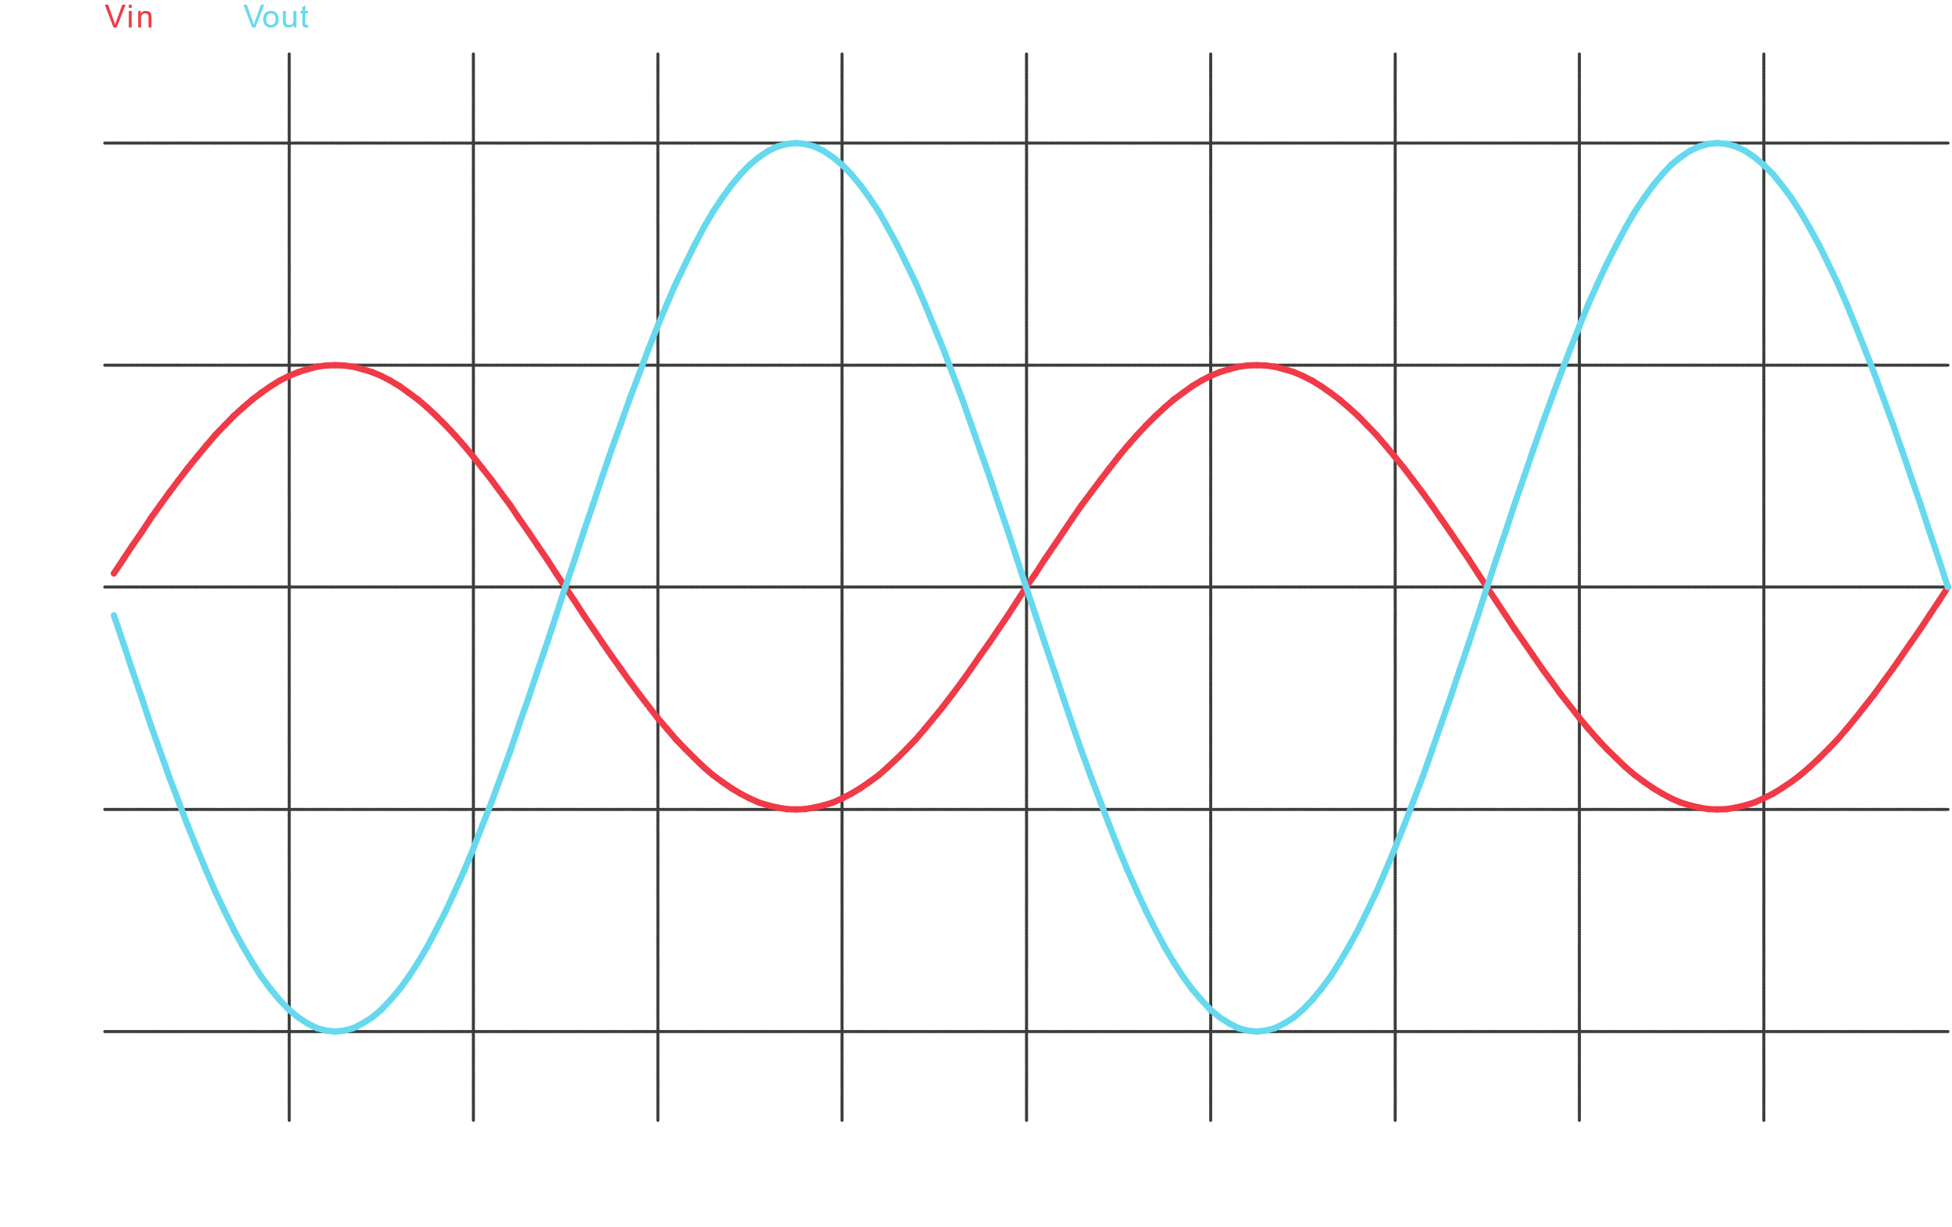

$$V_{out}=-\frac{R_{F}}{R_{i}}×V_{in}$$

$$A_{v}=\frac{V_{out}}{V_{in}}$$

$$=-\frac{R_{F}}{R_{i}}$$

$$=-\frac{20kΩ}{10kΩ}$$

$$=-2$$

Increasing input, output is clipped at $V_{out}=5V$ for $V_{in}>2.5V$.

**Task 5**

Circuit Diagram



For $V_{in2}=0V$,

Wave Shapes

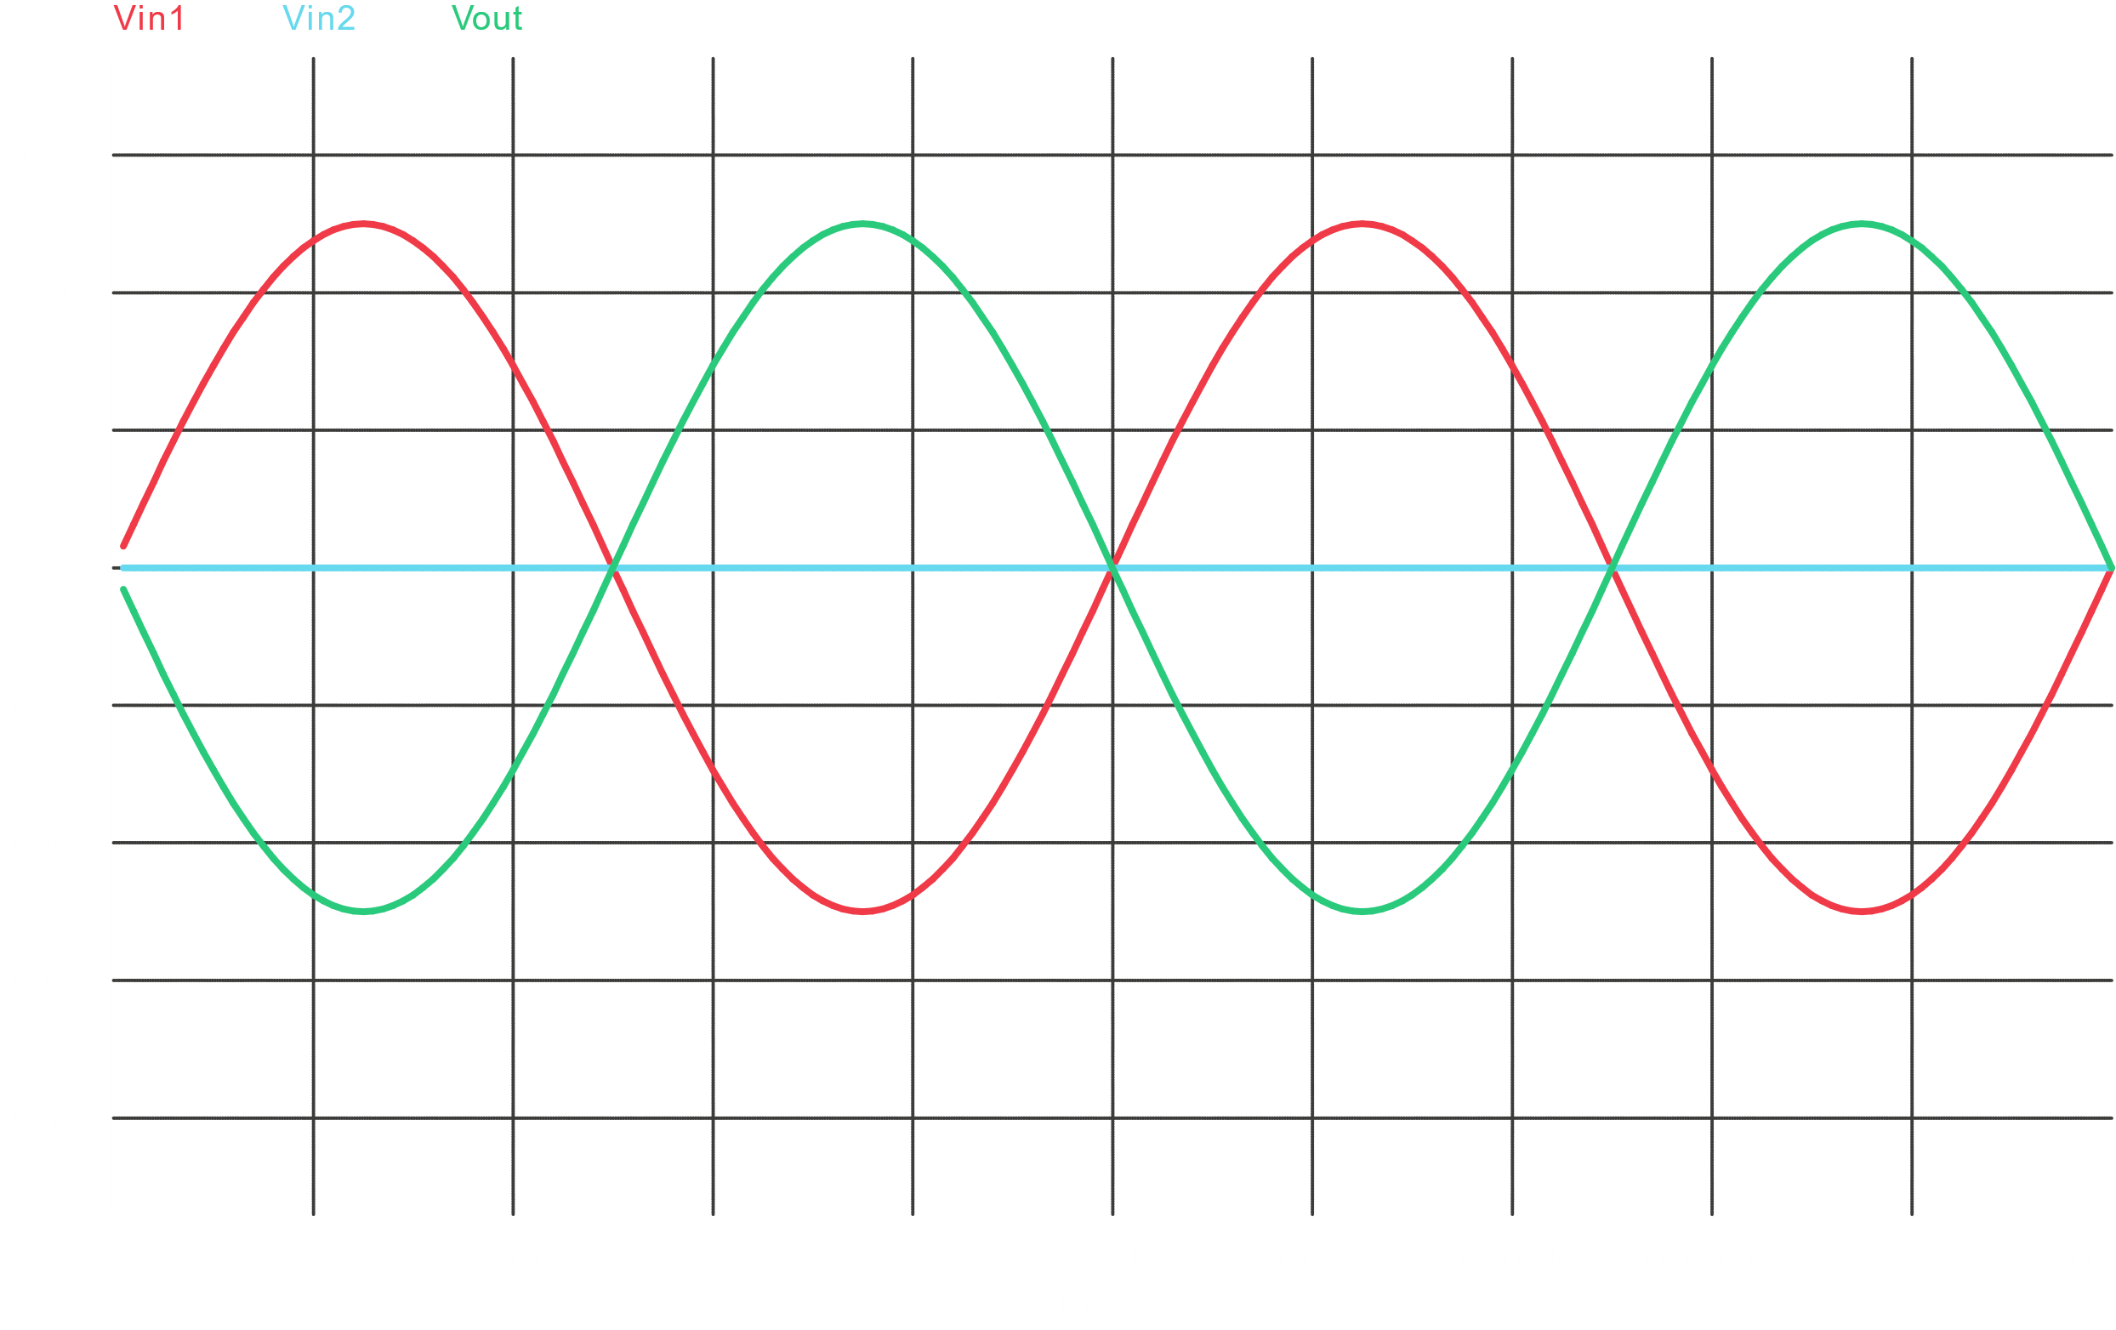

For $V_{in2}=+5V$,

Wave Shapes

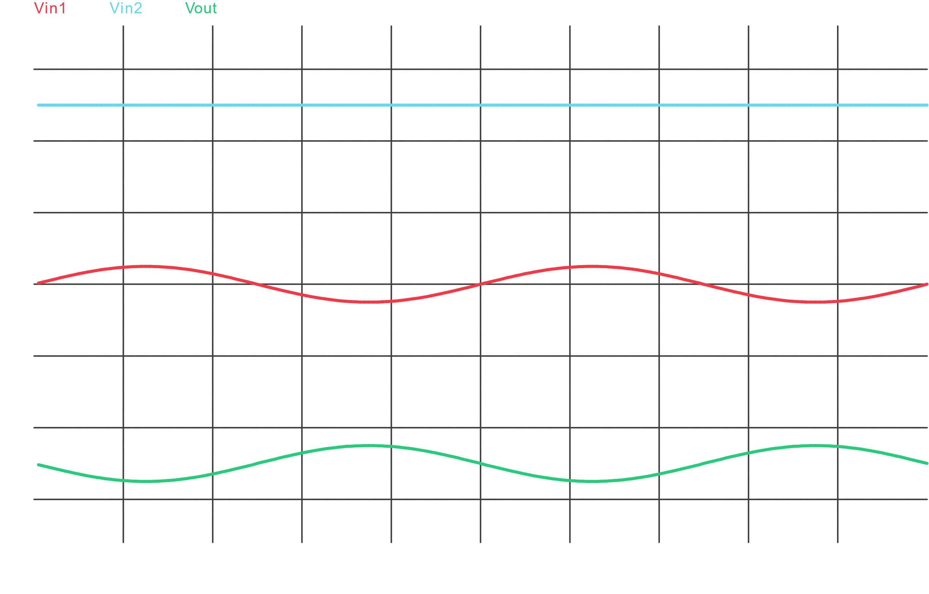

For $V_{in2}=-5V$,

Wave Shapes

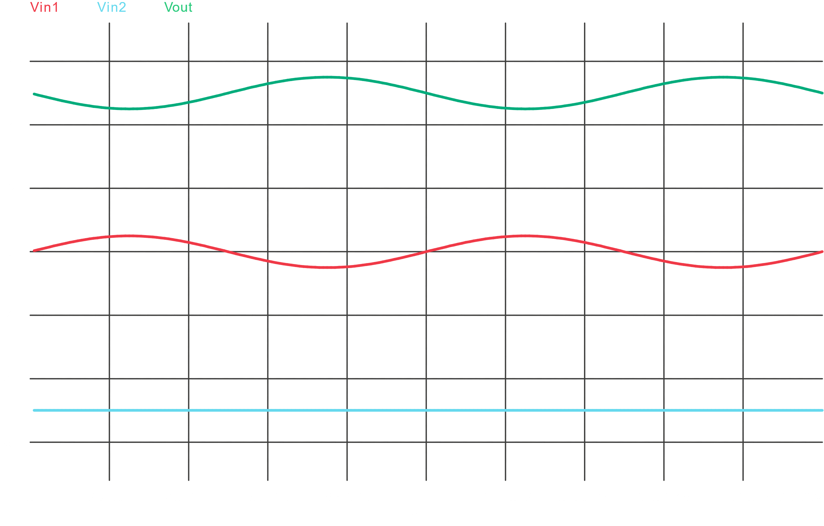

$$V_{out}=-\frac{R_{f}}{R_{1}}V_{in1}-\frac{R_{f}}{R_{2}}V_{in2}$$

**Task 6**

Circuit Diagram



Wave Shapes

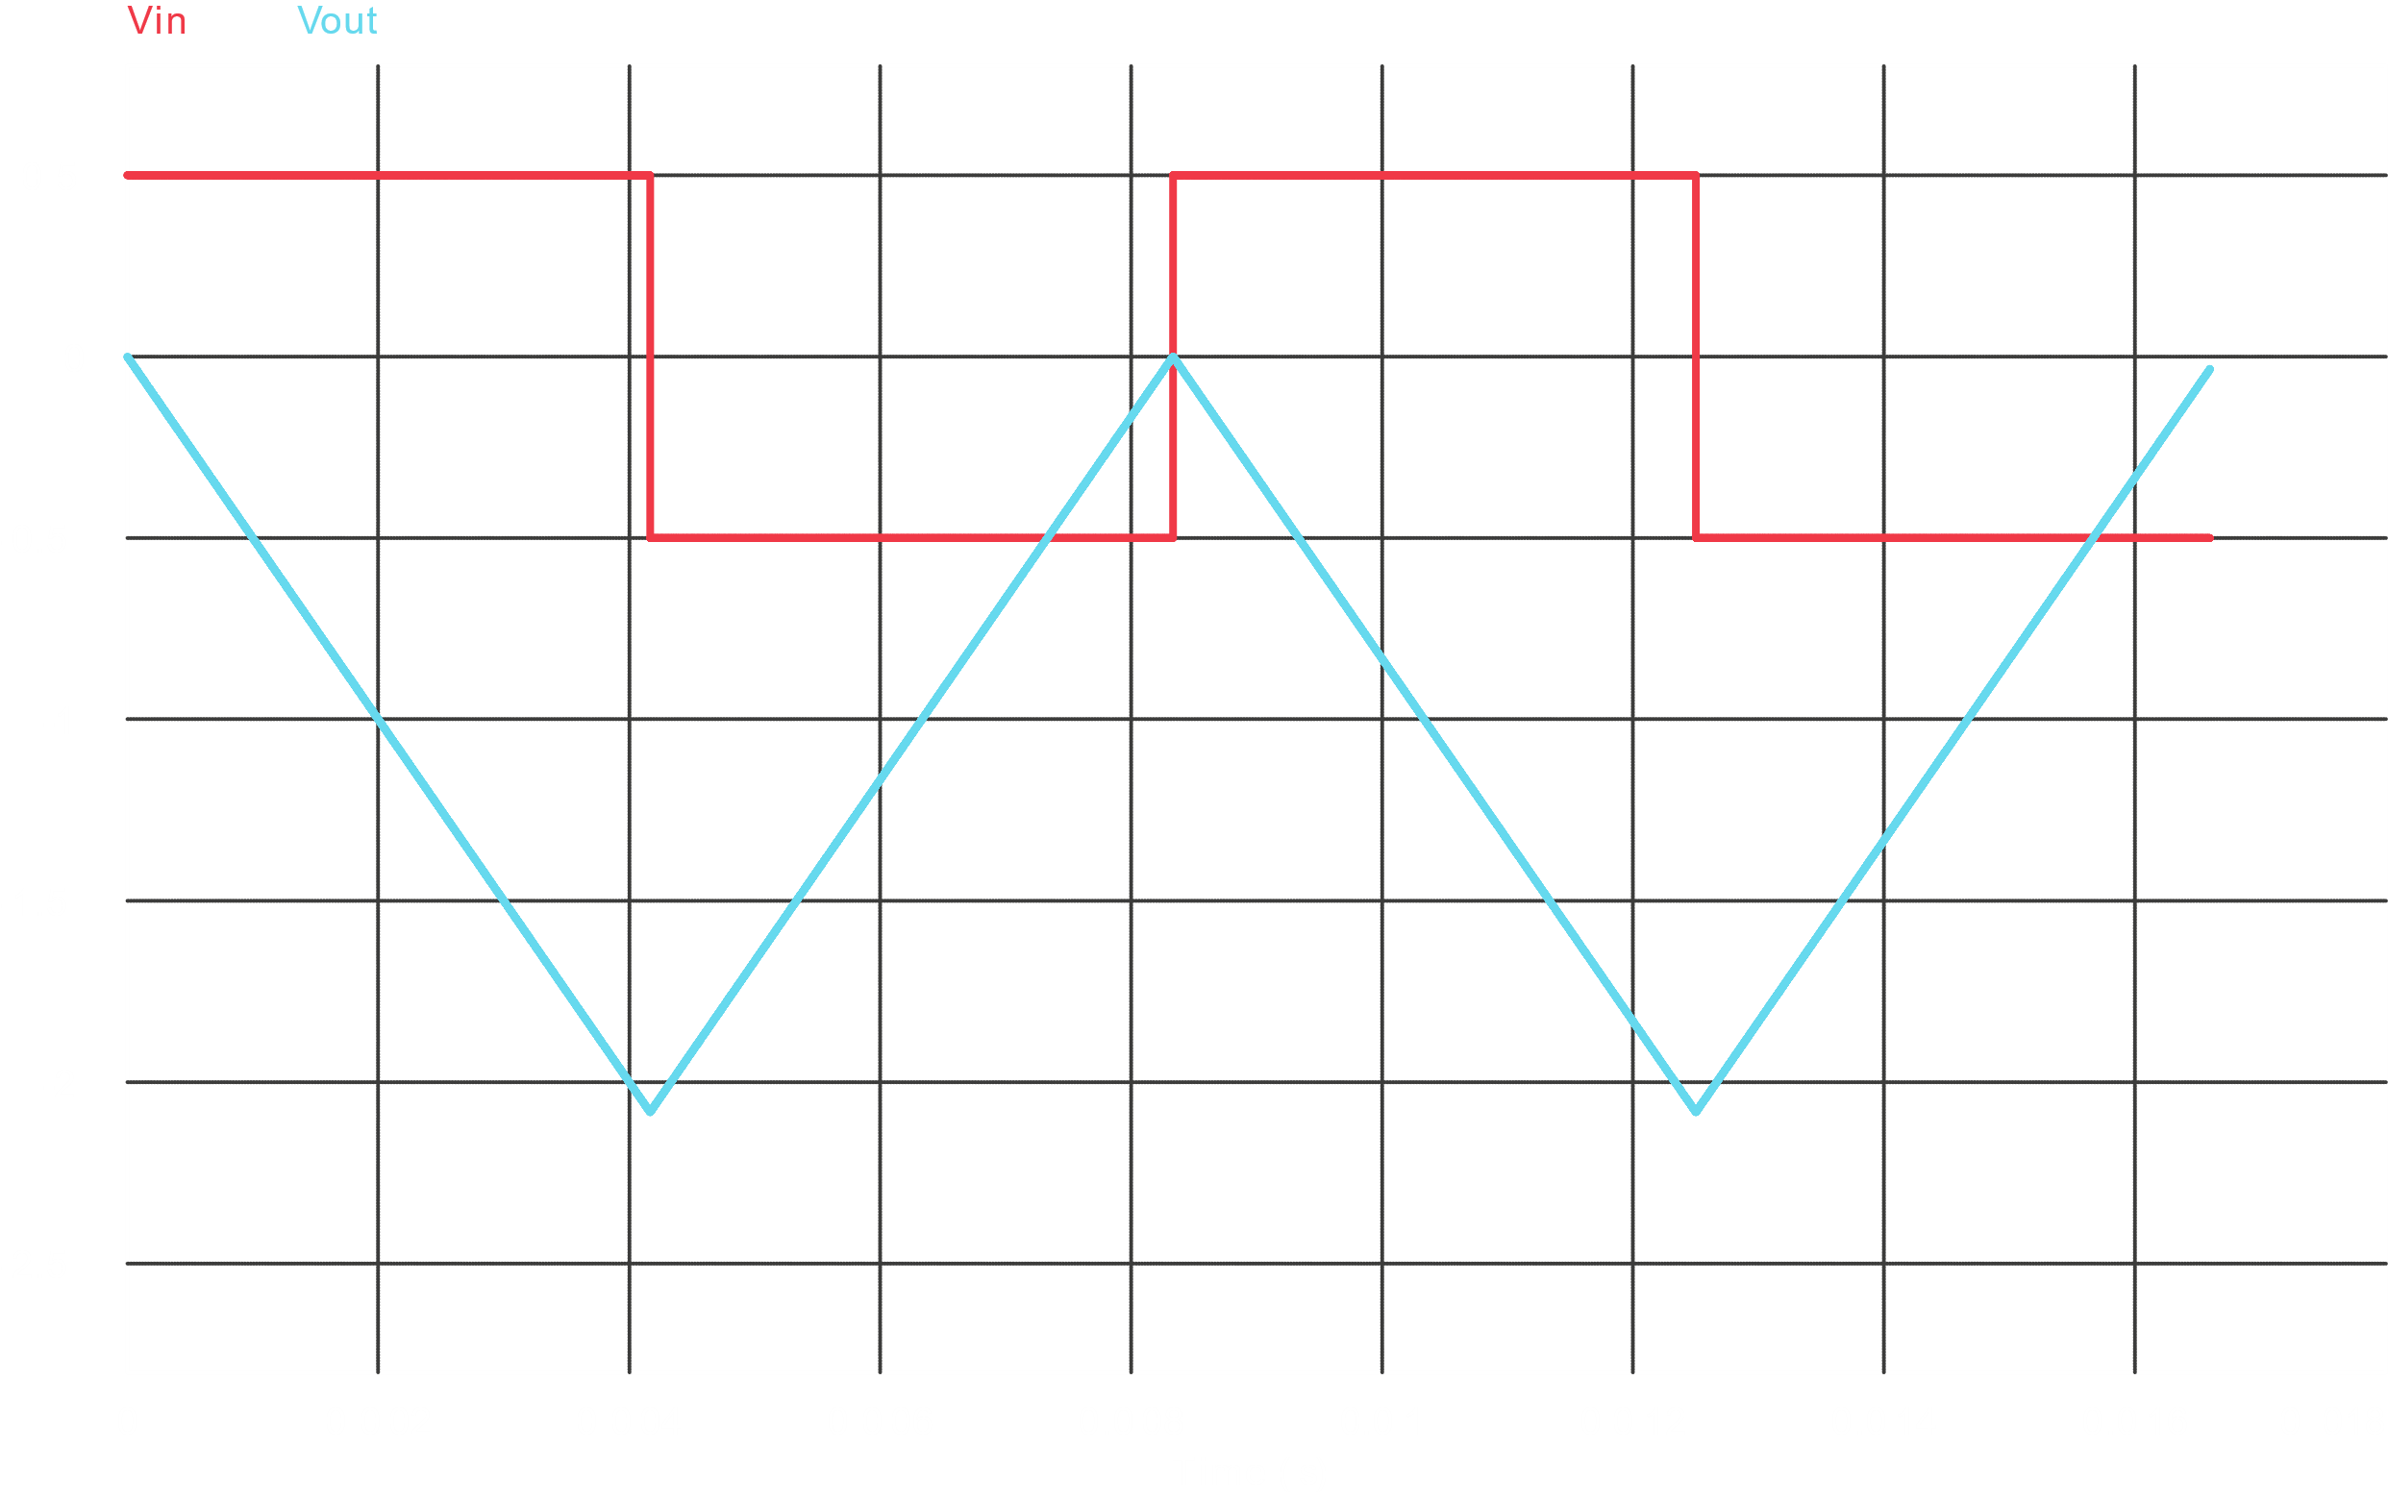

$$V_{out}=-\frac{1}{RC}\int_{0}^{t}{V_{in}dt}$$

**Task 7**

Circuit Diagram



Wave Shapes

$$V_{out}=-RC\frac{d}{dt}V_{in}$$